1. **Determine Token-Business Fit:**

Process: Identify the core functionalities of your business and how a token can enhance these functionalities.

Methodology: Conduct a SWOT (Strengths, Weaknesses, Opportunities, Threats) analysis to understand how a token can fit into your business model. Use the Value Proposition Canvas to understand how a token can deliver value to your customers.

1. **Determine the Chance of Success:**

Process: Analyze the market demand, competition, and potential growth of your token.

Methodology: Use market research and competitive analysis tools. Porter's Five Forces can help understand the competitive landscape. The Product-Market Fit framework can help assess the demand for your token.

1. **Determine the Properties of the Token:**

Process: Define the purpose of your token and its functionalities.

Methodology: Use the Token Classification Framework to identify the type and properties of your token.

1. **Give Tokens Intrinsic Value:**

Process: Define mechanisms that give your token value beyond speculation.

Methodology: This could involve backing the token with real-world assets, providing utility within your platform, or offering rewards to token holders.

1. **Establish Strategies to Raise Token Value:**

Process: Develop strategies to incentivize users to hold and use your token.

Methodology: This could involve staking rewards, profit sharing, or creating demand through utility within your platform. The Velocity Sink model can help manage token velocity and increase value.

1. **Establish Operational Strategies of Token Economy System:**

Process: Define the rules and mechanisms of your token economy.

Methodology: Use game theory to design incentive mechanisms. The Tokenomics model can help design the token distribution, rewards, and penalties.

1. **Establish Strategies for Token Liquidation:**

Process: Develop strategies to increase the liquidity of your token.

Methodology: This could involve listing on exchanges, creating a market maker, or partnering with other platforms for token use.

1. **Continue Modifying the Operational Base:**

Process: Regularly review and adjust your token economy based on performance and market changes.

Methodology: Use data analytics to monitor token performance. Agile methodologies can help make iterative improvements to your token economy.

**======================================================================**

**REQUIRED SKILLSETS**

— User/Market Research  
— Strategic Planning  
— Mechanism Design and Game Theory   
— Market Design   
— Behavioral Economics   
— Capital Markets   
— Operations Research   
— Financial Engineering   
— Advanced Mathematics   
— Blockchain/DLT Architecture   
— Systems Engineering   
— Network Science   
— Machine Learning and Data Science   
— Lean Startup and Agile Software Development   
— Design Thinking   
— Complex Systems

**PHASES IN THE TOKEN DESIGNING**

**— Discovery Phase**  
The discovery phase is to determine the particular characteristics of the business model or ecosystem and why a token is needed in the first place  
 **— Design Phase**The design phase consists of making high-level design choices including, governance structures, the (mathematical) token model and its parameters. These need to be optimized for stakeholders’ incentives and the long-term sustainability of the associated ecosystem in order to avoid value leakage  
 **— Deployment Phase**Finally, the deployment phase comprises of validating and stress-testing the parameters that were defined during the design phase, before fully integrating into the network.

* Token models to be iteratively optimized for parameters, better ranges, and token gravity. Token gravity is the flow of tokens with respect to different incentivization mechanisms.

**DELIVERABLES LIFECYCLE**

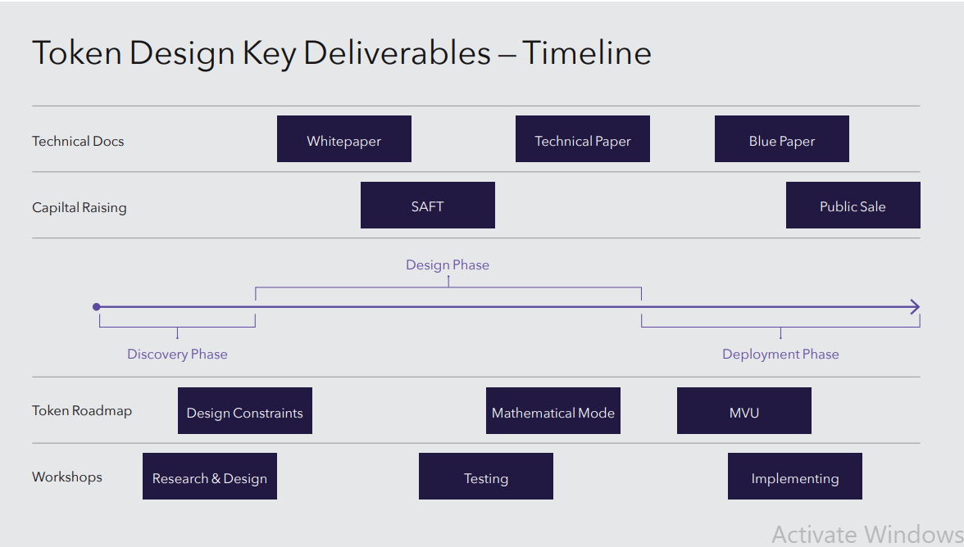

**DISCOVERY PHASE**

**Skills required** - Business planning, user research, business model innovation

* During this phase we begin with the most top to down approach and start by asking the right questions
* We need to identify an integrated set of challenges and solve it by a single token economy and also define the constraints of the problem at hand. Remember, the token economy may not solve the problem at hand 100% due to constraints.
* Use the MECE approach developed by Mckinsey for solving complex issues at hand by building a token economy. Read the MECE approach

**Problem Statement Worksheet - Identify the Actual Problem**

| **Core Question** | What is the core question to focus on? It should be specific, measurable, action-oriented, relevant, and time-bound (SMART) while ensuring it is not so narrow that it excludes critical issues |
| --- | --- |
| **Context** | Here we lay out the complexity we’re facing and that will need to be met. |
| **Criteria for Success** | Here we define what success for the project looks like, and should include qualitative and quantitative measures. |
| **Scope of Solution Space** | Identify the parameters of the solution - what will/will not be included in the solution set. |
| **Constraints of Solution Space** | Determine the limits/boundaries of the solution set. |
| **Stakeholders** | Key Agents in the ecosystem |
| **Key Sources of Insight** | Locate key areas where learnings could come from |

**Logic Trees**

* The token models' core problems should be dissected into distinct mutually exclusive problems and then these major problems should be dissected into sub-problems.
* The logic tree should outline the problems in such a manner that the problems are mutually exclusive and completely exhaustive.

**Taxonomy of Actors**

* Categorization and understanding of different participants in the token economy.
* These actors have different roles, incentives, and responsibilities in the token economy
* Most common actors are

1. **Token Holders**: These are the individuals or entities that own the tokens. They can be further divided into different categories based on their behavior or intent, such as users, investors, or speculators.
2. **Users**: These are the individuals or entities that use the tokens for their intended purpose within the platform. For example, in a decentralized file storage system, users might spend tokens to purchase storage space.
3. **Investors**: These are the individuals or entities that purchase and hold tokens as an investment, with the expectation that the tokens will increase in value over time.
4. **Speculators**: These are the individuals or entities that buy and sell tokens to profit from short-term price fluctuations.
5. **Developers**: These are the individuals or entities that build and maintain the platform or protocol. They may be incentivized through token rewards.
6. **Miners/Validators**: In blockchain-based token economies, these are the individuals or entities that validate transactions and add them to the blockchain. They are typically rewarded with tokens for their work.
7. **Regulators**: These are government or regulatory bodies that may impose rules and regulations on the token economy.

**Stakeholder Mapping**

* Understanding each stakeholder's expectations, interests, and influence on the token economy
* Stakeholder mapping is used to align the incentive mechanisms with the stakeholder's expectations/interests.
* Which stakeholders influence the other stakeholders with the most priority?
* Ideally you should be able to identify who’s at the top of the foodchain

**Steps Involved**

1. Identify all possible relevant stakeholders. Keep in mind that a stakeholder can also be a negative actor to be controlled and/or optimized out of a system.
2. Define and analyse the respective roles and multi-directional relationships in the ecosystem.
3. Whiteboard the system as a pathway / network. Position and connect the stakeholders who influence and impact each other the most in priority lanes.

**Value Exchange Mapping**

* This is a process of identifying and analyzing the exchanges of value that occur within the token economy.
* Value can be exchanged in many forms, including tokens, services, information, or any other assets that stakeholders find valuable.
* The mapping process involves understanding how value flows between different stakeholders and how these exchanges are facilitated by the token.
* This information can then be used to design a token economy that maximizes value for all stakeholders.
* In the context of a token economy, value exchange mapping can help in understanding how the token is used within the system and how it can be designed to facilitate valuable exchanges.

**Steps Involved**

1. Take the outcomes of the stakeholder mapping, mainly the definition of each stakeholder and their roles.
2. Explore how each actor may benefit. The most obvious is through compensation, however, consider other meaningful rewards as well. Focus on how and if they can be rewarded. While this is a conceptual exercise to intuitively explore financial exchange, and it involves the need to work through the specific financials; it may also involve considering non-monetary rewards. Reciprocity also expands the definition of value to ensure that everyone wins in these broader terms. To do a reciprocity analysis, keep in mind the following points
3. Look at comparable systems. If it is a new space, look for analogous cases. Undertake an ecosystem analysis, examining value exchanges and the value stack.
4. Determine priorities in the set of objectives. Examples: do users care more about security or privacy? Which incentives or stakeholders matter more?
5. Illustrate the exchange of value between them. Begin to prototype the system into a single ecosystem that connects stakeholders to the delivery of the solution. Use sticky notes and large surfaces to whiteboard the potential solution and value exchange system.
6. Look for additional sources of growth and revenue. While obvious ways to generate revenue (for example, transactions) may already have been identified, this is the time to look for additional growth initiatives
7. Conduct a comparative analysis. Examine competing or analogous markets to understand efficiencies and inefficiencies. Pay attention to how value is created and the costs and capabilities involved.
8. Hypothesize, prototype, iterate, and refine. Create an initial prototype and assess whether this is the most business-viable and technically feasible way to deliver the proposed solution. Examine if there are other ways to go about this. A key point to consider should be: how sustainable is this model over the long term and how could it be disintermediated or disrupted?
9. Evaluate the unique role of the ‘foundation’. Determine how the foundation is uniquely positioned to develop the network and succeed. Focus on the existing capabilities and interdependent relationships, and determine if these can be distinctly leveraged to contribute to success and competitive advantage. In this context, a foundation refers to a non-profit organization established to administer governance over the network

**Token Utility Canvas - Outlier Ventures**

1. Further token utility canvases to explore are mentioned below
2. <https://media.consensys.net/tokenwork-introducing-the-token-utility-canvas-tuc-9a1f32979dc0>
3. <https://medium.com/paperchain/introducing-the-protocol-canvas-designing-better-decentralized-protocols-1aa89c1858ba>
4. <https://medium.com/@nembal/token-engineering-canvas-agent-behaviour-map-basics-for-token-engineering-59a413001222>

* The token utility canvas is divided into two parts.
* One is a business-centric matrix and the other is a network-centric matrix.

**Business Centric Matrix**

| **Token** | **Value Proposition** | **Experience** |
| --- | --- | --- |
| Type | Value Creation | Personas |
| Use & Role | Value Capture | Channels |
| Underlying Value |  | Journey Map |

**Network Centric Matrix**

* There are two layers in the network-centric matrix

1. Market Layer. At the market layer, the economics of the ecosystem is designed to align the distribution of value in order to achieve a more efficient market.
2. Ledger Layer. the ledger layer is where key attributes of each transaction need to be verified and simple contracts need to be executed.

**Token Types**

1. Assets - These tokens cryptographically represent traditional assets. An example is tether.
2. Usage tokens - Provide access to a digital service. Think of them as a paid API key. Their utility is derived from that of the decentralized digital service. An example is FILE coin.
3. Work Tokens - Provide the right to contribute to the network. An example is Curve tokens

**Roles & Purposes**

1. Digital currency - Medium of exchange and/or store of value. Example is bitcoin
2. Network token - Provides functionality within a specific network. Example is etheruem
3. Investment - This kind of token can be used to invest in the issuing network/entity, or underlying asset, and used to distribute benefits of any success or appreciation. Example is BCAP tokens which represent an indirect fractional non-voting economic interest in Blockchain Capital, a venture capital company investing in blockchain technology companies.

**Underlying Value**

1. Asset backed - NFT’s. Allow for trading of that underlying asset. Example is cryptokitties
2. Network Value - These tokens are tied to the value and development of the network and linked to key interactions between network participants and the value exchanged over the network. Example is Eth
3. Share like - These tokens grant rights to a share in the success of the issuing entity or underlying asset. E.g. the short-lived DAO token.

**Outputs/Deliverables for Discovery Phase**

1. Business requirements doc
2. Stakeholders mapping
3. Value exchange mapping
4. Taxonomy of actors
5. Token utility canvas

**DESIGN PHASE**

**Skills required -** Mechanism Design/Game Theory, Market Design, Behavioral Economics, Blockchain/DLT Architecture, Systems Engineering, Network Science

During this phase we develop

1. An understanding of the incentives for each participant in the ecosystem
2. An understanding of the associated business model
3. An understanding of of the market structure
4. An understanding of he network structure
5. The deliverables of the discovery phase are iteratively improved to create the most critical input of the current phase which is the “Taxonomy of Actors”

**Networks Objective Function (NOF)**

* Determining network participants and their roles is a critical dependency for the next step of defining
* The Network Objective Function is the primary objective we want the network to optimize for above all else, and helps us aggregate the different goals of a particular network depending on their relevant importance. Equally as important as a network’s objective function are the model’s constraints, a requirement in the design of safe systems. This is the most important output of the design phase.
* For example, MakerDao’s network objective function is to maintain the stability of its stablecoin, DAI, pegged to the US dollar, while ensuring the overall health and security of the system. This is achieved through a combination of mechanisms including collateralization, governance, and automatic adjustments of parameters.

**Steps Involved in Creating NOF**

1. **Identify all potential network participants**. By developing user/participant profiles and personas we can attempt to uncover participant motivations and objectives. This step is crucial because it allows us to understand the dynamics driving the actions of different types of agents - be they autonomous, irrational or partially rational humans or malignant - according to different objective functions.
2. **Define and analyse the respective roles and strategy profiles of network agents**. This shows us what actions each participant can take and each participant type’s utility function. This step also allows us to figure out the participants’ self-interest vs. the best interest of the network (for example, overall ecosystem performance)
3. **Define multi-directional relationships, and hence strategic interactions in the network**. This is to decide what extrinsic and intrinsic value transfers can be expected within the ecosystem. We need to determine the possible resulting outcomes of these strategic interactions, and see if they are compatible with the overall aim/health of the network.
4. **Define population characteristics that are likely to arise**. For example, which level of rationality/ thinking are the participants likely to exhibit? Which proportion of the population is likely to show altruistic or malignant tendencies? Here we need to examine level-k thinking and Keynesian beauty contest game.

**Design Tools**

* Since tokens allow ecosystems to self-coordinate and self-manage in an efficient manner, below are a few tools to streamline the entire process
* <https://web.stanford.edu/~jacksonm/netbook.pdf>
* <https://labs.engineering.asu.edu/acs/wp-content/uploads/sites/33/2016/09/Consensus-and-Cooperation-in-Networked-Multi-Agent-Systems-2007.pdf>

**GANTT Charts**

* GANTT should be used internally by all the members of the crypto-economics team throughout the token design process to manage resources and timelines

**Javelin Boards**

* It is used to track and validate assumptions and ideas and is broken in two sections. Below is an example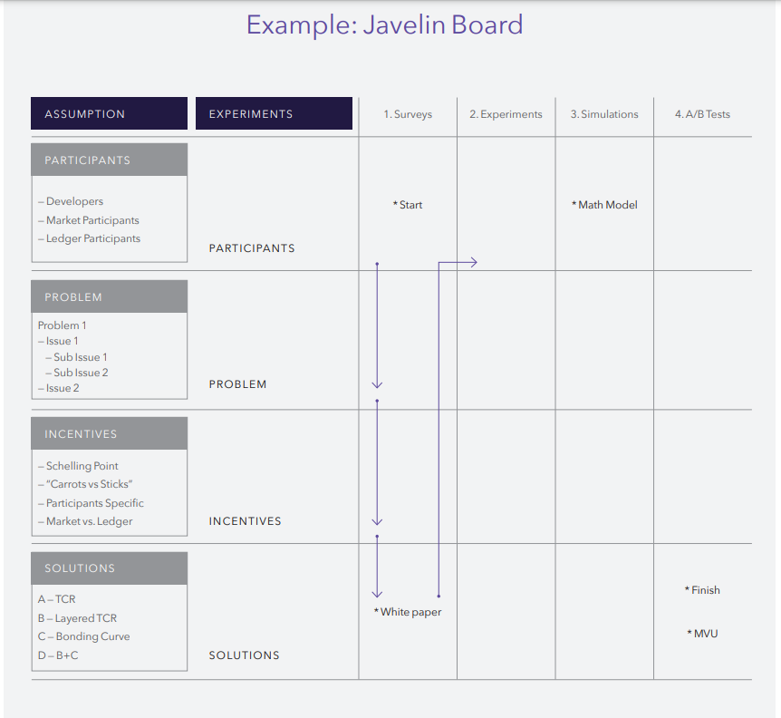

**Components of the Javelin Board**

**Assumptions**

* Here, all assumptions regarding the token model should be clearly laid out.
* Below is a description of each section and which assumptions should be included on the board to be tested.

1. Participants. Who are the network participants? Break them down by market and ledger layers.
2. Problem. Break the problem into two components: core problems (macro, market gap/opportunity, competition), and periphery problems (micro, technical, user specific, design problems).
3. Incentives. What is the Schelling Point? (equilibrium with zero communication/ coordination), distinguish and classify incentives and penalties (carrots and sticks). Distill incentives down to specific participants, and specific roles within the market and ledger layers.
4. Solution. This deals with actual token design, the idea is to break design into its most basic components and then test all combination of design primitives.

**Experiments**

* In this section, every assumption in the above category needs to be validated through experimentation. Experiments should be run sequentially from top to bottom and from left to right

**Top to Bottom**

* The results from testing down through Participants=>Problem=>Incentives=>Solution all feed into the next sequence of experiments and mark the creation of the first interactive feedback loop in the token design. This feedback loop is critical and should be present across all stages of the token design.

**Left to Right**

* Experiments gradually become more sophisticated and specific, starting with simple surveys, then moving to experiments, modeling and simulations, and then A/B testing.

**Design Methodologies**

**Game Theory**

* Game theory is the study of multi-person decision problems and a crucial tool in the token design process, since it helps us determine the outcomes from strategic interaction of players given their preferences and incentives.
* Unlike decision theory that is concerned with the individual’s own preferences and constraints, game theory is about interactive decisions and shows us how players can make decisions in competitive and/or cooperative environments.
* <https://scholar.harvard.edu/files/nali/files/gamedisopt_conf.pdf>
* Below are some game theory models which can be used to construct token economies

1. **Prisoner's Dilemma:** This model can be used to understand situations where individual participants acting in their own self-interest do not result in the optimal outcome for the system as a whole. It can help in designing mechanisms that encourage cooperation among participants.
2. **Public Goods Game:** This model can be used to understand situations where participants can contribute to a common good that benefits everyone. It can help in designing incentives that encourage participants to contribute to the common good rather than free-riding on the contributions of others.
3. **Stag Hunt:** This model can be used to understand situations where participants can choose between a risky cooperative strategy that has high potential rewards and a safe non-cooperative strategy that has lower rewards. It can help in designing mechanisms that encourage risk-taking and cooperation.
4. **Nash Equilibrium:** This concept can be used to understand situations where no participant can gain by unilaterally changing their strategy while the other participants keep theirs unchanged. It can help in designing stable systems where participants have no incentive to deviate from their current strategies.

* Additionally, expected utility theory allows us to convert preferences into outcomes and rational decision-making implies that agents will seek to maximize their expected utility over outcomes

**Mechanism Design**

* It's the art of designing game rules to achieve a specific outcome.
* Unlike game theory, which takes game rules as given, mechanism design sets the game structure.
* It uses the framework of game theory with incomplete information to study the consequences of different rules.
* In the context of token economies, it influences network outcomes and determines the optimal network design.
* Below are the parts to define a mechanism design

1. **Setting Game Rules**

* The environment and the actors participating in the game need to be defined.
* This involves describing the participants, potential decisions, preferences for each participant, and any private information they may hold.
* The taxonomy of actors is a key input in the design phase.

1. **Token Utility**

* A well-designed token creates powerful incentives that drive network activity.
* Understanding how a token’s utility drives behavior is a critical aspect of the token design process.

1. **Market Design**

* It involves designing a market structure to achieve desirable properties.
* The market design should facilitate efficient outcomes and allow enough potential transactions at one time.
* It should prevent any single type of agent from possessing the power to influence the market.
* There should be enough time for offers to be made, accepted, rejected, and for transactions to be carried out.
* It should be safe for participants to reveal their preferences truthfully.
* <https://web.stanford.edu/~alroth/alroth.html>. This is a goldmine for more mechanism designs, game theory models.

**Behavioral and Experimental Economics**

**Behavioral Economics**

* Studies economic questions while incorporating learnings from psychology.
* Traditional economic models assume rational behavior, but humans have limited cognitive abilities, lack motivation and self-control, and their behavior may change based on context and reference points.
* Seemingly insignificant factors can have huge effects on people’s decisions, so the presentation of a token's functionality is as important as the actual mechanisms.

**Experimental Economics**

* Helps test assumptions and findings by isolating key causal relationships between business environments, agent behavior, and consumer choices.
* Controls for irrelevant effects, allowing focus on specific factors.

**Randomized Control Trials (RCTs)**

* Participants are randomly assigned to treatment (receive the intervention) vs. control groups (do not receive the intervention).
* Randomization allows for objective comparison of the effectiveness of treatment.
* In each treatment, one single factor can be changed to determine its effect on participants’ incentives, behavior, and the ecosystem.

**Implementation Fields for Testing**

* Smaller and simpler versions of a project’s economy/interactions can be replicated with users taking various representative roles within the network.
* Potential implementation fields for experimentally testing a specific behavior include MTurk and Experimental Labs.
* Empirical data provided by existing networks can be analyzed, and natural experiments within them can be identified and studied.

**Models for BE, EE, RCT’s and Testing**

**Behavioral Economics Models**

* **Prospect Theory:** This theory suggests that people make decisions based on the potential value of losses and gains rather than the final outcome. This can be used in token design to understand how people might react to potential rewards and penalties.
* **Nudge Theory:** This theory suggests that positive reinforcement and indirect suggestions can influence the behavior and decision-making of groups or individuals. This can be used in token design to encourage certain behaviors without forcing them.
* **Hyperbolic Discounting:** This model suggests that people prefer smaller, immediate rewards over larger, later rewards. This can be used in token design to structure incentives that are effective in the short term.

**Experimental Economics Models**

* **Double Auction Markets:** This is a market in which buyers and sellers submit bids and offers simultaneously, and transactions occur when bids and offers match. This can be used to test how participants in a token economy might react to different market conditions.
* **Public Goods Games:** This is a game in which players choose how much to contribute to a public good that benefits all players. This can be used to test how participants in a token economy might cooperate or free-ride.

**Randomized Control Trials Models**

* **A/B Testing:** This is a method of comparing two versions of a webpage or other product to see which one performs better. This can be used in token design to test different versions of a token economy.
* **Factorial Designs:** This is a method in which multiple factors are varied independently to determine their effect on the outcome. This can be used in token design to test the impact of different elements of the token economy.

**Implementation Fields for Testing Models**

* **MTurk:** Amazon's Mechanical Turk (MTurk) is a crowdsourcing marketplace that can be used to conduct experiments with a large number of participants.
* **Experimental Labs:** These are controlled environments in which experiments can be conducted under controlled conditions. Examples include university research labs or virtual labs like oTree.
* **Existing Networks:** Existing blockchain networks can provide empirical data for analysis. Natural experiments within these networks can be identified and studied.

**Cryptographic Designing Primitives**

* **Schelling Point:** Knowing the Schelling Point, or focal point, of a network is a crucial first step in designing a token model. The Schelling Point is a solution that people tend to choose in the absence of communication because it seems natural or special to them.
* **Cost-Benefit Analysis:** The complexity and cost of adding any additional mechanism to the token model should be proportionally less than the added coordination it provides. The risk is that added complexity could negate the benefits of increased coordination.
* **Minimum Viable Token (MVT):** The token architect should limit the design of the MVT to the simplest design possible. A minimal Viable Token for our purposes is the simplest but most effective design possible to deliver upon the Objective Function, within a system’s set constraints, determined during the token design process.
* **Testing Cryptographic Tools:** Many of the proposed cryptographic tools have undergone limited testing by the community. These tools could become 'trusted' through the deployment phase of the token design, which includes validation and testing.
* **Trust in Tools:** When designing a token model, especially the MVT, the network designer should focus on using minimal combinations of tools that can be initially 'trusted'.

**Design Process**

* The steps for the design process are composed of designing various sub mechanisms as mentioned below

1. **Incentives & Mechanisms**

* The design process includes a component known as Ledger-Market Fit.
* Tokens operate between two distinct but complementary layers: the market layer and the ledger layer.
* The market layer is where network participants interact and transact, often off-chain. This is where the business model is formulated and incorporated, taking into account network effects and externalities.
* The ledger layer is where all necessary transactions and other relevant information are ordered and recorded.
* Token models act as the interface between these two layers, limiting and incentivizing behavior in the market layer, and acting as the sensor funneling data onto the ledger layer to be recorded.
* To design for Ledger-Market Fit, the network architect needs to determine the needs of the market and the business model, induce participants to reveal their preferences and/or hidden information truthfully in that market, and create the correct incentives in recording in and sustaining the ledger itself.
* This process requires understanding the constraints and computational feasibility of running a specific market on a particular ledger.

1. **Participant incentives**

* Incentives play a crucial role in economic or contractual relationships, aiming to induce network participants to act in a particular way.
* Participants can partake in the token ecosystem either via interacting with each other at the market layer, by becoming nodes to sustain the ledger layer, or both. Correct assumptions about the possible types and designing the right incentives matter at both these layers.
* The team designing the network will need to determine who will be the network nodes, what information or type of transactions should go into the ledger, what type of identity management should be used for which type of ecosystem activity, and whether different types of participants need to be treated differently.
* The rationality level of different types of participants in the network can vary greatly, and its effects on the ecosystem should be tested or simulated.
* Each incentive mechanism is an assumption/hypothesis until it can be validated through experimentation. This process is similar to the lean startup approach where assumptions of a business model are validated before implementation/codification.
* The goal is not only to explore if proposed incentives work, but to determine to what extent and the reason why it worked (or didn’t).
* The steps involved are:

1. Create hypotheses based on the defined participants’ incentives.
2. Formulate ways to test this hypothesis and decide the best avenue for testing. Consider if experiments are the best option for testing, if they can be set up quickly enough, if there will be enough statistical power to detect any effect from experimental observations, or if it's better to go for interviews, surveys, or simulations.
3. Determine the best way to measure the success of future testing. Define what successful validation of the incentive should be.
4. Note learning/key insights for the future, whether the testing/experiment was determined to be successful, or not.

b. **Reputation Mechanisms**

* Identity management is a critical element for both ledger and market layer activities.
* On the ledger layer, identity management is key to securing sensitive data, onboarding and offboarding nodes, and establishing a protocol’s governance model(<https://arxiv.org/pdf/1708.04872.pdf>)
* In the market layer, one of the major challenges token designers face is ensuring enough trust remains on the network to avoid value leakage, so that transactions between relative strangers remain efficient enough to support the viability of the network.
* Reputation mechanisms seek to solve this problem by building trust and hence facilitating transactions.
* When designing a reputation mechanism, decisions around what information each participant should have about each other, and the level of flexibility network participants should have in deciding who they want to interact with need to be determined.
* Reviews have historically been the cornerstone of reputation mechanisms and can be a potentially powerful tool for tokenized networks.
* However, these review mechanisms do present some vulnerabilities. Specifically, participants or businesses can be incentivized to manipulate and distort these reviews.
* A review reader may not consider a representative sample of the population by, for example, focusing on either very positive or negative reviews and subsequently making suboptimal decisions due to selection bias (<https://www.hbs.edu/ris/Publication%20Files/17-017_ec4ccdc0-4348-4eb9-9f46-86e1ac696b4f.pdf>)

**c. Network & Token Supply Governance**

* Design a process to answer the following questions

1. Who will participate in making decisions for the ecosystem; how will these participants be chosen; and what decisions will each participant or group of participants be responsible for?
2. How will decision-makers be held accountable for decisions and how can decision-makers be changed?
3. What level of automation in the collective decision-making process will there be?
4. Which class of decisions process will remain onchain vs. off-chain?

* Put in place consensus mechanisms to increase coordination with minimal complexity

d. **Consensus Mechanisms**

* When designing consensus mechanisms as an economical design tool, the following high-level components should be reviewed (<https://arxiv.org/pdf/1708.04872.pdf>)

1. Network Topology: shows the type of interconnection between nodes (decentralized, hierarchical, centralized).
2. Immutability and Failure Tolerance: each consensus protocol has its own unique set of attack vectors.
3. Gossiping: how is the addition of new blocks communicated to the rest of the network?
4. Consensus agreement: how do nodes communicate between themselves, and how does the system handle Byzantine failures (latency, finality)?

* If designing our own unique distributed ledger as opposed to building on totp of an existing protocol, see the “Consensus Evaluation Framework” from this research paper (<https://arxiv.org/pdf/1711.03936.pdf>)

e. **Monetary & Fiscal Policy**

* Token supply governance involves decisions regarding the monetary and fiscal policy of the token, which has important implications for the adoption and sustainability of the business model and the surrounding ecosystem (<https://www.researchgate.net/profile/Avtar-Sehra/publication/351626829_Economics_of_Initial_Coin_Offerings/links/60a25a0045851528ebedaf9c/Economics-of-Initial-Coin-Offerings.pdf>)
* Monetary and fiscal policy tools should be employed considering the effects of different types of token allocation mechanisms, token velocity, and sale structure on the network.
* Monetary policy refers to the overall management of the token supply regarding the amount that will be released and the level of automation involved in the process.
* Decisions regarding the total number of tokens to be issued, the minting process, and the frequency and timing of the release of tokens have important implications on token velocity and overall ecosystem health.
* The token architect needs to make decisions regarding Fixed vs. flexible token supply - Whether the token supply should be kept fixed, follow an expansionary path, or be subjected to a decay function.
* Automation - The degree of automation involved regarding the release of tokens into the ecosystem or expansion or decay of the overall token supply.
* Method of release of tokens including partnerships, public sales, and/or airdropping them.
* A fixed supply of tokens can create the synergies needed in the initial investment process and drive token prices higher which can be useful for the initial ecosystem pick-up. However, it may also lead to volatility and speculation in the market, limiting the token’s adoption as a medium-of-exchange and its sustainability.
* Flexible token supply involves creating an expansionary and/or contractionary token supply policy. An expansionary (contractionary) policy means that the token issuer will increase (decrease) token supply over time.
* The level of automation involved in the governance of the network and the token supply is a complex task. However, automation helps networks function without relying on particular input from individuals and can help avoid bottlenecks and issues related to trust.
* Deciding how to match the issued tokens with ecosystem participants is the last step. There are currently many methods of adding token supply into networks, including enterprise partnerships with bonus tokens to end users, airdrops, and public sales.
* Fiscal policy involves other methods of dealing with the allocation of the issued tokens in order to promote community engagement within the ecosystem. For example, the foundation, the token issuer, or alternatively the whole community via some consensus mechanism may decide to offer subsidies to certain types of network participants.

**f. Token Distribution**

* The distribution of tokens can significantly impact the overall functioning of the network and general system safety.
* Bootstrapping network development and initial liquidity sometimes requires capital raising through a token sale.
* Token sales, either private or public, can concentrate initial token distribution in the hands of early investors, which can be an issue for ecosystems founded on a decentralized ethos.
* Decentralizing token distribution is a key initial step to drive adoption rates and ensure the relative decentralization of an ecosystem’s consensus formation, protocol value, protocol improvements, conflict resolution, and platform development.
* There is a risk of premature decentralization. Distributing tokens to users before any tangible utility is offered by the network can turn potential users into hodlers, which can destabilize the network if there's a sudden drop or increase in price.
* Successful networks will likely need strategic long-term investors to bootstrap development and initial liquidity.
* Networks need to ensure that their tokens are effectively distributed to key stakeholders and that all required roles are adequately filled, at the right time.
* Token sales are one way to distribute tokens, but early investors (or token buyers) aren’t necessarily the target users of the network.
* Airdrops are a useful mechanism to distribute tokens to actual users and bootstrap communities. However, they need to be coupled with a targeting strategy that focuses on delivering tokens to targeted user personas and attaching the airdrop to actual usage of the network (<https://medium.com/ideo-colab/airdrops-key-themes-and-design-considerations-efadc8d5d471>)
* Every network’s Airdrop strategy should be informed by its stakeholder maps and taxonomy of actors.
* Staged token sales can be used to target strategic investors before network utility is fully developed, and subsequently, actual users once a network is fully launched. However, structuring a token sale effectively locks a network into an economic model that may not be optimal.
* DAICOs are a new fundraising approach proposed by Vitalik Buterin that combines elements of both a ‘DAO’ (decentralized autonomous organization) and an ‘ICO’. DAICOs allow a team to bootstrap their project by collecting funds from investors in an escrow account that is collectively controlled by investors.
* Developer and bounty programs are a suitable way to crowdsource specific tasks relating to network development, a TGE, or bug fixes. However, there is no guarantee that those developers who receive tokens will end up joining or starting the developer community around the network.
* Corporate partnerships and sales can be used to distribute tokens into the hands of the right users. However, relying too much on this strategy can end up concentrating tokens into the hands of large corporate groups which could then use their weight to push their own agenda on issues such as governance.
* Token sales conducted pre-MVT launch do not offer any utility and are likely to be classified as a security. The SEC is more likely to classify tokens as a utility token that are sold post MVT launch.
* Two tokens models, involving a security and utility token targeted at different users is a potential solution currently being explored by many actors in the space.
* The SEC recently announced that it officially accounts for a network’s level of ‘decentralization’ into its legal opinions as to whether a token is a security or a utility. Therefore, in order for a token to be classified as a utility, the issuing network also needs to exhibit decentralized qualities along with offering empirical utility.
* Staged token sales can be used to target strategic investors before network utility is fully developed, and subsequently, actual users once a network is fully launched. However, structuring a token sale effectively locks a network into an economic model that may not be optimal.
* DAICOs are a new fundraising approach proposed by Vitalik Buterin that combines elements of both a ‘DAO’ (decentralized autonomous organization) and an ‘ICO’. DAICOs allow a team to bootstrap their project by collecting funds from investors in an escrow account that is collectively controlled by investors.
* Developer and bounty programs are a suitable way to crowdsource specific tasks relating to network development, a TGE, or bug fixes. However, there is no guarantee that those developers who receive tokens will end up joining or starting the developer community around the network.
* Corporate partnerships and sales can be used to distribute tokens into the hands of the right users. However, relying too much on this strategy can end up concentrating tokens into the hands of large corporate groups which could then use their weight to push their own agenda on issues such as governance.
* Token sales conducted pre-MVT launch do not offer any utility and are likely to be classified as a security. The SEC is more likely to classify tokens as a utility token that are sold post MVT launch.
* Two tokens models, involving a security and utility token targeted at different users is a potential solution currently being explored by many actors in the space.
* The SEC recently announced that it officially accounts for a network’s level of ‘decentralization’ into its legal opinions as to whether a token is a security or a utility. Therefore, in order for a token to be classified as a utility, the issuing network also needs to exhibit decentralized qualities along with offering empirical utility.
* Token utility (<https://medium.com/@cdixon/crypto-tokens-a-breakthrough-in-open-network-design-e600975be2ef>)

**Key Design Outputs**

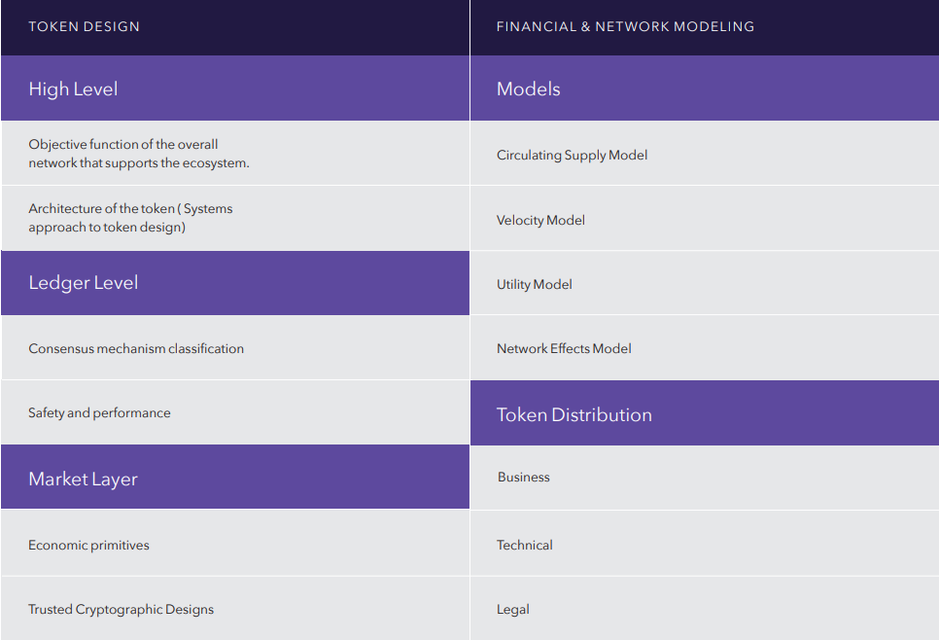

**Defining Network Objective Function & Constraints**

* Steps involved  
  1. Identify network goals. For example, degree of decentralization, governance, voting rights/ consensus building, scalability, do we want to minimize type 1 or 2 error (if relevant) etc.  
  2. Prioritize among network goals, which are determined in step 1.   
    
  3. Determine the weights (or range of weights) that are relevant for each factor and the shape of the overall objective function.   
    
  4. Define the associated constraints. For example, incentive-compatibility, a threshold to participate in curating or consensus building, computing capacity

**Token Architecture**

* Systems Approach to Token Design: This involves mapping out the entire system, including its architecture, user interactions, and value flows across the ecosystem and within each subsystem.
* Example - Artonomous: This is an open-sourced autonomous artist project. It's a self-sufficient artist that creates and sells its own art. It earns money through a daily art auction and by issuing and selling its own tokens.
* System Mapping: This involves describing the various states of each subsystem and the mechanisms that drive state changes across the system as a whole. This allows for clear visualization and mathematical description of causal loops between state changes in different subsystems and their constraints.
* State Variables: In the Artonomous ecosystem, five state variables are defined - Gallery, Pool, Supply, Votes, and Candidates. These are used to design the system in terms of its state variables on the blockchain.
* Roles: Six roles are characterized - Caller, Collector, Patron, Voter, Generator, and Developer. These are sets of Ethereum addresses from which user actions are taken or from where Artonomous derives information.
* Mechanisms: Seven mechanisms are defined - Art Generation, Art Sale, Patron Bonding, Patron Staking, Patron Unstaking, Patron Withdrawal, and Generator Proposal. These interact within the ecosystem and represent the action space available in this complex system. Patron mechanisms refer to actions related to minting, staking, unstaking, and burning of Soul tokens (<https://github.com/BlockScience/artonomous/blob/master/token_engineering/Artonomous.pdf>)